Computer networks Lab programs
------------------------------------------------

- Implement the data link layer framing methods such as character, character-stuffing and bit stuffing
Bit Stuffing
Bit stuffing is a technique in which we add extra bits to a given set of data. The added bits don't carry any information butrather they help in better communication. It is all about protocol management.
Character Stuffing
Character stuffing or Byte Stuffing is the technique of adding a particular byte to the data section before every byte in thedata having the same pattern as the flag.
In Character destuffing while traversing the data we delete the byte with the same pattern as the given flag and continuestraversing the given data frame.
Logic
- For character stuffing we will create a character array of the given data. While traversing the array as we reach the byte (which is == to the flag) we will append the flag before it. We also add the flag byte at the start also at the end ofthe data frame.
- For character destuffing we will create a character array for the given data and while traversing we will increment the variable count (initially zero) whenever we reach the byte (which is == to the flag). When count%2==0 we will delete thecurrent byte and reset the variable count=0 and continue traversing.
- Then we will create a class that will take the input string/data as an argument and will convert the given data into binary data for further implementation.
- For bit stuffing we will create an array of the given data and while traversing the array if '1' occurs five times we will append a '0' after them (ex. 111110) to the array.
- For bit destuffing we will create an array of the given data and while traversing we will delete all the '0s' that occurredafter five '1s'.

Character-stuffing Program :-

import java.util.Scanner;

public class CharacterStuffing {
public static void main(String[] args) {
String[] frame = new String[100];
String[] str = new String[50];
String flag = "flag";
String esc = "esc";

int k = 0;
Scanner sc = new Scanner(System.in);

// Add starting flag
frame[k++] = flag;

System.out.print("Enter number of strings: ");
int n = sc.nextInt();
System.out.println("Enter the strings:");
// Read input strings
for (int i = 0; i < n; i++) {
str[i] = sc.next();
}
// Display entered strings
System.out.println("\nYou've entered:");
for (int i = 0; i < n; i++) {
System.out.println(str[i]);
}
// Perform character stuffing
for (int i = 0; i < n; i++) {

if (str[i].equals(flag) || str[i].equals(esc)) {
frame[k++] = esc;
}
frame[k++] = str[i];
}

// Add ending flag
frame[k++] = flag;
// Display stuffed frame
System.out.println("\nByte Stuffing at Sender Side:\n");
for (int i = 0; i < k; i++) {

System.out.print(frame[i] + "\t");
}

System.out.println();

sc.close();
}
}
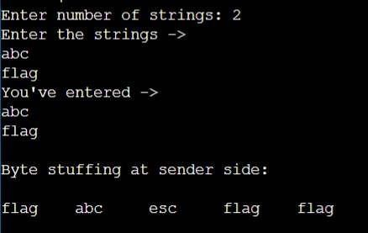

Bit-stuffing
Program
import java.util.Scanner;
public class BitStuffing {
public static void main(String[] args) {
Scanner sc = new Scanner(System.in);
System.out.print("Enter the bit string: ");
String str = sc.next();
StringBuilder stuffed = new StringBuilder();
int count = 0;
for (int i = 0; i < str.length(); i++)
{
if (str.charAt(i) == '1')
{
count++;
}
else {
count = 0;
}
if (count == 6) {
stuffed.append('0');
count = 0;
}
stuffed.append(str.charAt(i));
}
System.out.println("String after bit stuffing: " + stuffed);
sc.close();
}
}

Output :-
